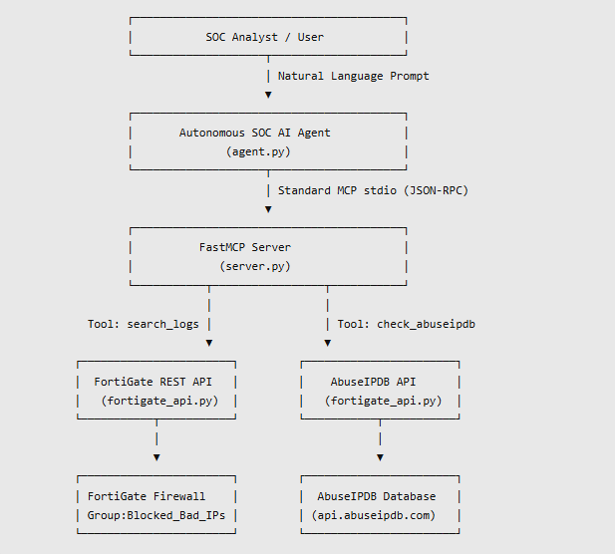

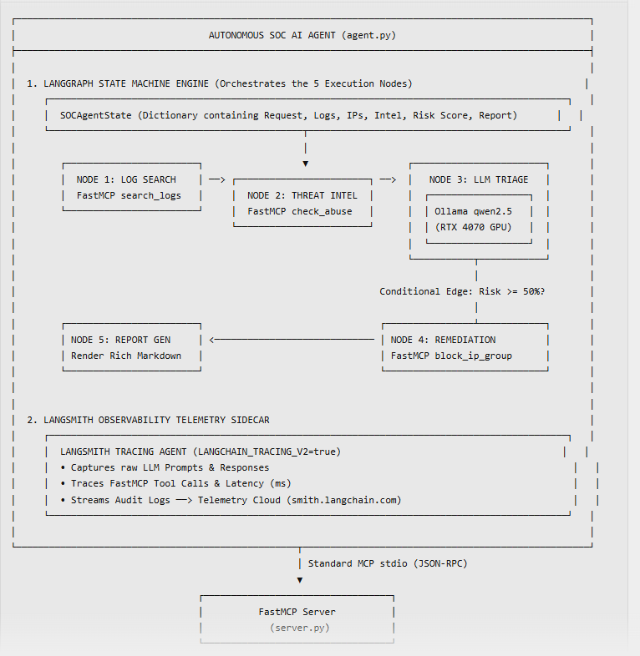

Component-by-Component Map
1. Where is LangGraph?
- Location: Inside agent.py.
- Role: It is the State Machine Framework (StateGraph) that builds the pipeline.
- Instead of running a linear script, LangGraph moves the SOCAgentState dictionary through 5 distinct Nodes (Node 1 ➡️ Node 2 ➡️ Node 3 ➡️ Node 4 ➡️ Node 5) and evaluates Conditional Edges (e.g. route_triage).

2. Where is the LLM (qwen2.5:latest)?
- Location: Inside Node 3 (node_llm_gpu_triage) of the LangGraph state machine.
- Hardware: Runs locally via Ollama on your MSI Raider GE68 (NVIDIA RTX 4070 GPU).
- Role: Node 3 takes the raw firewall logs and AbuseIPDB scores collected by Nodes 1 & 2, sends them to qwen2.5 via ChatOllama, and receives the Contextual Risk Assessment Score (0-100) and reasoning.

3. Where is LangSmith?
- Location: An active background telemetry collector connected to agent.py.
- Role: Every time LangGraph executes a Node, invokes the Ollama LLM, or calls a FastMCP tool (search_fortigate_logs, block_ip_in_fortigate_group), LangSmith automatically intercepts and uploads the trace to your dashboard at smith.langchain.com.

Updated Masterclass Architecture Diagram (Full Detail) 